Raspberry Pi 2B

Button: 1 lead to GPIO, 1 to GND

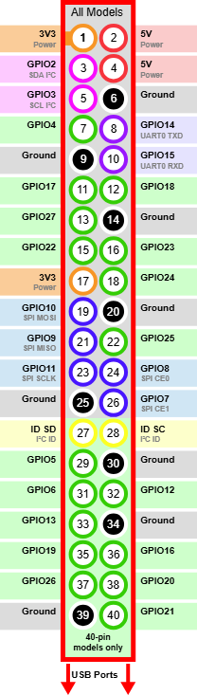

Raspberry Pi 5
1x USB3.0 port: SSD for data output
1x USB2.0 port: Audio in for timecode generator
1x RJ45 Ethernet port to connect to LAN for access to UR3e & Gripper server

